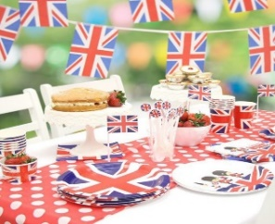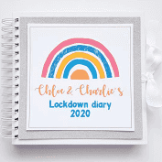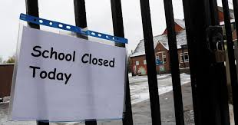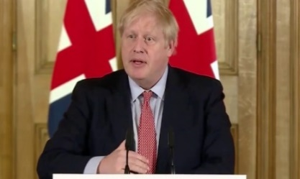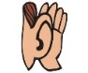\\SR-001\Users$\lwalker\Documents\2019-2020\summer\circle time cards\b6e2aea298775ffdfbc0b06a40c57bb8_eyes-clipart-for-kids-free-download-best-eyes-clipart-for-kids-_571-188.png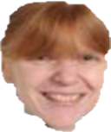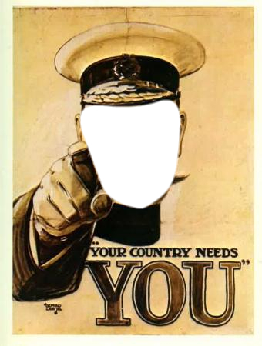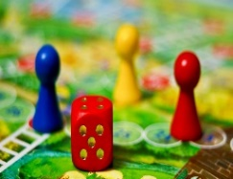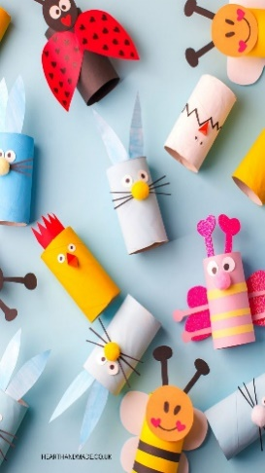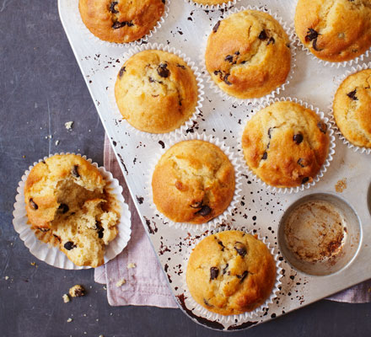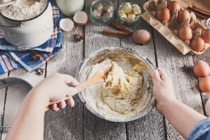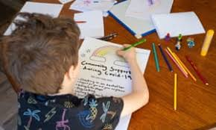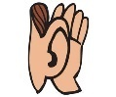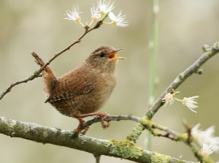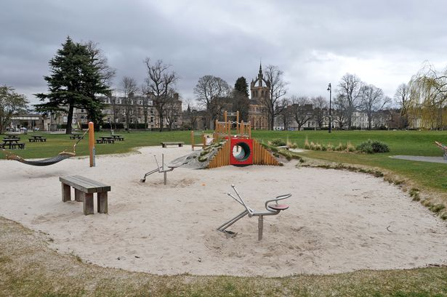\\SR-001\Users$\lwalker\Documents\2019-2020\summer\circle time cards\b6e2aea298775ffdfbc0b06a40c57bb8_eyes-clipart-for-kids-free-download-best-eyes-clipart-for-kids-_571-188.png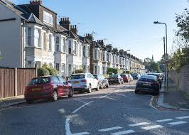

20th March marked the start of Lockdown when Dogsthorpe Infant School, along with schools all over England, closed its doors at the end of the day. The Prime Minister, Boris Johnson, made his announcement on 18th March that due to the Coronavirus all schools and a lot of businesses would not be open. This has led to lots of children and adults working from home! The message was: Stay At Home.

**New sights and sounds of Lockdown**

**Have you noticed how different everything has looked and sounded during Lockdown?**

These are a few different sights and sounds you might have noticed – I bet you can think of lots more!

Keeping in touch during Lockdown.

Because we cannot see our relatives or friends we have been keeping in touch on line via computers/ipads or mobile phones.



crafts

drawing

Lockdown Memories: Some people are recording their memories of Lockdown so that we can look back on these strange and unique times.

**Here are some ideas you could do:**

**Make a Lockdown Scrapbook** – stick photographs or pictures you have made during this time. Write something about each one. Ask an adult if you can put some appropriate newspaper cuttings in too. This link gives ideas:. <https://blog.kidadl.com/articles/how-to-make-lockdown-memory-scrapbooks>

**Make a daily diary** which could also

include pictures – writing about what you

have been doing. You could write or

draw about what you have seen or heard or felt.

**What have you and your family been doing?**

**We have all been trying to keep ourselves busy by doing different activities.**

Stay at Home Party

games

baking

**Dogsthorpe Infants School needs you!**

It would be great if you could send us some pictures or writing of memories you have of Lockdown – it could be what you have been doing which is special or different or what you have seen or heard or noticed during this time. How has it made you feel? You could write a poem if you would like to.

Can hear birds singing because there’s less noise.

Empty and quiet parks.

Cars parked outside houses all day because adults are staying at home. Less traffic noise on the road means roads are quieter.

**Lockdown Memories**