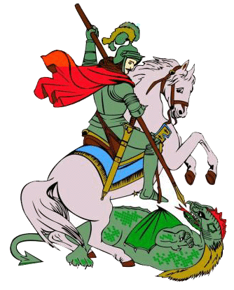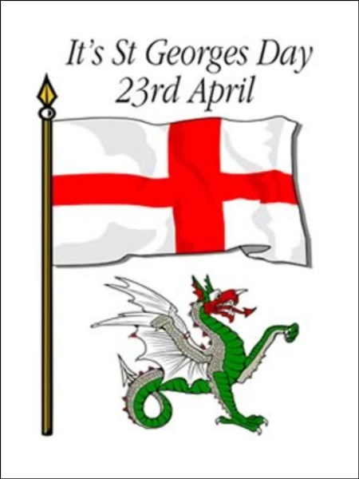

Activities:

Reception: Make an English Flag with St George’s Cross on it. You can create it using tissue paper collage, or colour using felt tips/crayons or paint it.

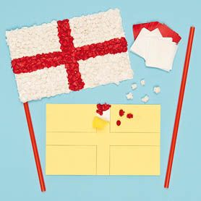

Year 1 and Year 2: Create a poster of St George killing the Dragon and saving the princess.

Everyone: Check out some fun ideas and activities on the cbeebies website to celebrate St George’s Day:

<https://www.bbc.co.uk/cbeebies/watch/lets-celebrate-st-georges-day>

The Story of St George slaying the dragon.

* A town was terrorised by a dragon.
* A young princess was offered to the dragon.
* When George heard about this he rode into the village.
* George slayed the dragon and rescued the princess.

23rd April is St George’s Day!

Lots of people celebrate St George’s Day. But who was he? What did he do? Here are some facts!

**St George’s Day**

* A red cross on a white background was St. George’s emblem. This is now the English flag.
* St. George’s flag was adopted by Richard the Lion Heart and brought to England in the 12th century. Soldiers wore it on their tunics to avoid confusion in battle.
* The real St. George is believed to have been a brave Roman Soldier who protested against the Romans being unkind to Christians.

