Helping your child

learn at home in

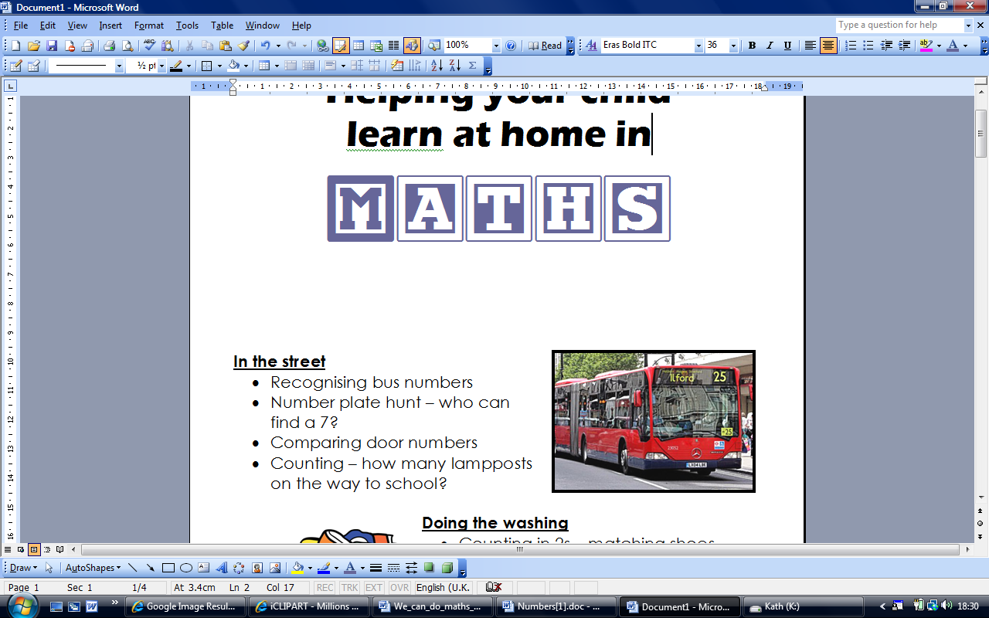

**In the street**

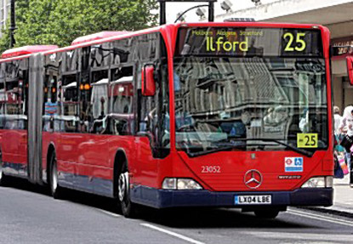

* Recognising bus numbers
* Number plate hunt. Who can find a 7? Add the numbers up.
* Comparing door numbers
* Counting – how many lampposts on the way to school?

**Doing the washing**



* Counting in 2s – matching shoes
* Sorting by colour and size.
* Matching/pairing up socks.
* Find four shoes that are different sizes. Can you put them in order.

**Time**

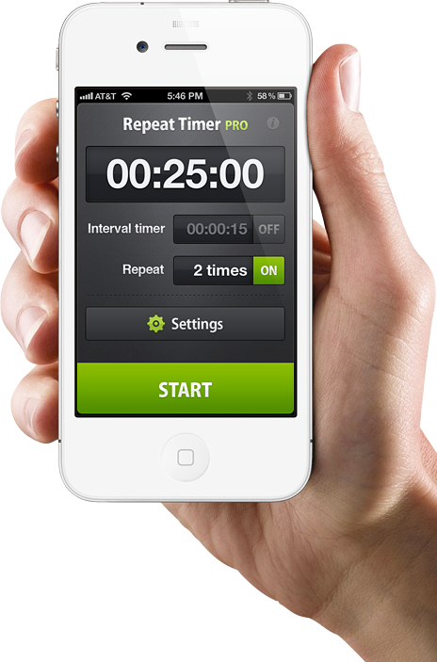

* What day is it yesterday, today, tomorrow?
* Use timers, phones and clocks to measure short periods of time.
* Count down 10/ 20 seconds to get to the table/ into bed etc.
* Recognising numbers on the clock. If you cover a number, what number was missing?

**Food!**

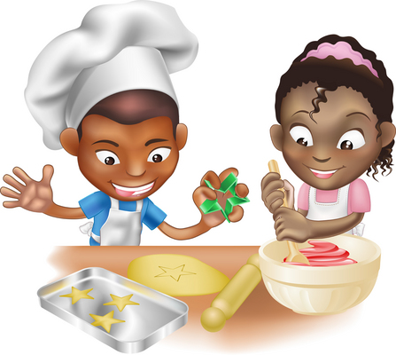

* Can you cut your toast into 4 pieces? Can you cut it into triangles?
* Setting the table. Counting the right number of plates etc. How many more do we need?
* Can you make shapes/ patterns out of the knives and forks. Can you put them in the right place in the drawers?
* Helping with the cooking by measuring and counting ingredients.
* Setting the timer.
* Positional language at dinner time: what is on the rice, where are the carrots etc?

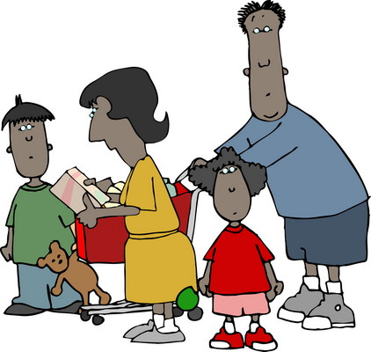

**Going shopping**

* Reading price tags
* Counting items into the basket
* Finding and counting coins
* Comparing weights – which is heavier

**Measuring**

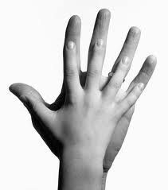

* Are you taller than a …?
* Marking height on the wall.
* Cut hand shapes out of paper. How many hands long is the couch? How long is the table? Which is longer?
* Who has the biggest hands in our family?
* How many steps from the gate to the front door?

**Shapes**

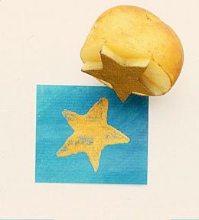

* Cut a potato into shapes (circles, triangle etc). Use with paint to make pictures and patterns.
* Cut out shapes from coloured paper/ newspaper and arrange into pictures.
* Shape hunt: Can you find a square in your house (windows etc), a circle …

**Playdough**

Here’s a simple recipe:

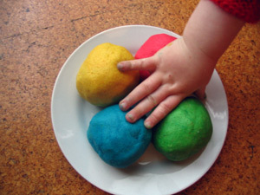

***1 cup of plain flour***

***1 cup of water***

***1 tablespoon cooking oil***

***2 teaspoons cream of tartar***

***Half a cup of salt***

***food colouring and essences (optional)***

*Put all ingredients in a large saucepan, and heat slowly, stirring all the time until it forms a ball. Keep it wrapped in clingfilm or in a covered tub to stop it drying out.*

Then ….

* Make numerals and shapes
* Sort shapes into groups, or order by size
* Make long and short wiggly snakes.

**Games**

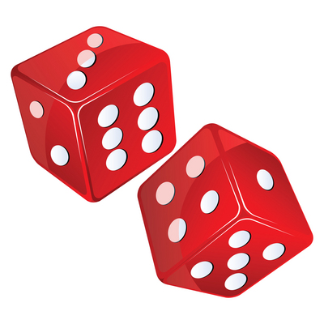

* Putting cards into piles
* Jigsaws (you can make your own by cutting up a magazine picture)
* Snap (matching pairs) or Happy Families (collect 4 of a kind)
* Snakes and ladders or other simple dice games.

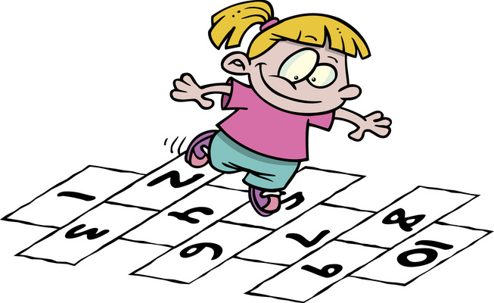

* Adding numbers on two dice.
* Bingo, with numbers or shapes
* Hopscotch

**Number rhymes and songs**

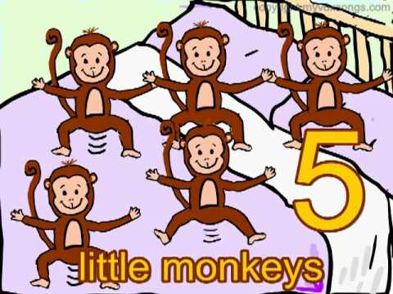

*Eg: 5 little monkeys jumping on the bed*

*One fell off and bumped his head*

*Mummy called the doctor and the doctor said*

*“No more monkeys jumping on the bed!”*

*4 little monkeys jumping on the bed …*

Your child can teach you lots more or try this website which has the words and sings it for you:

http://www.nurseryrhymes4u.com/NURSERY_RHYMES/COUNTING.html

**Internet maths games:**

www.mathszone.co.uk

http://www.bbc.co.uk/bitesize/ks1/maths/

http://www.familylearning.org.uk/online_math_games.html

www.sesamestreet.org

